AL-FARABI KAZAKH NATIONAL UNIVERSITY

Law faculty

Department of customs, financial and environmental law

THE FINAL EXAM PROGRAM
Discipline: MKEP 5206 International conventions in energy law

Specialty - 7M04212 «Maritime and energy law»

Course-1 Semester-1
Number of credits –5
Form of study: full-time, distance

Almaty, 2024

The compiler of the program of the final exam in the discipline: G.Teleuyev
The educational program 7M04212 «Maritime and energy law» is developed on the basis of the curriculum
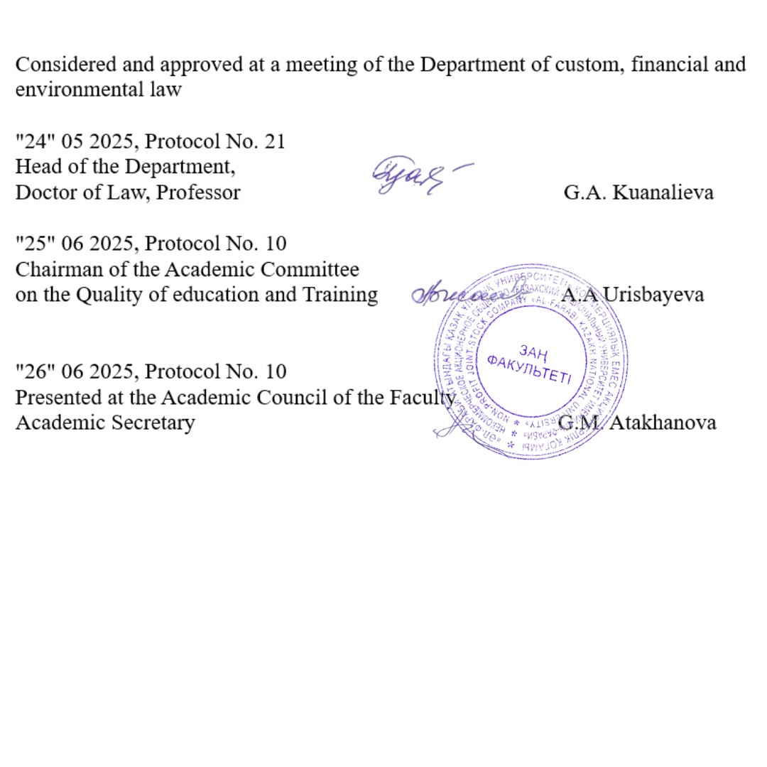

Introduction
Studying in the master's program is carried out in accordance with the State Standard of Compulsory Education of the Republic of Kazakhstan and academic policy, the study of the discipline ends with a final exam, which consists of passing the exam. Only undergraduates who have scored the appropriate points upon completion of the educational process in the discipline in accordance with the curricula and working curricula of the master program are allowed to the examination and final control. The exam is held on the dates specified in the Academic calendar and the working curriculum.
Undergraduates who have received an unsatisfactory grade, passing the final control for this period is allowed only with the payment of the loan and re-training. An appeal is possible. A graduate student who received an unsatisfactory grade on the exam results is registered for re- training by order of the university, if he received 25 points for the exam, then FX retake. Documents for health reasons issued after receiving an unsatisfactory grade are not considered. Retaking an exam to encourage grades is not allowed.
Final exam on “Environmental safety in maritime and energy law” will be held in verbal form online, in according to exam schedule.

Description of the forms of conducting final control (exam).
- For admission to the exam, you must score at least 50 points for the current performance in the discipline (Level control 1, intermediate control, arithmetic mean, level control 2).
- Master students studying on a paid basis for admission to the exam should not have debts in tuition fees.
- The exam is conducted verbally. The form and schedule of the exam are indicated in the Univer system.
- During the exam, it is strictly forbidden to use or receive cheat sheets, mobile phones, smart watches and other means for transmitting information, communicate with other students and strangers and / or make other identification records in response.
- The use of additional information during verbal examination is strictly prohibited.
- The undergraduate does not have the right to open a ticket in front of the examining teacher to take the exam.
- The exam is held online via service on the corporate Microsoft Teams platform of Al- Farabi KazNU or in case of technical problems, external ZOOM resources. During the verbal examination, video recording is mandatory. The examination score can be canceled in case of violations this procedure by the undergraduate.
- At the end of the exam, the points scored by students within 48 hours are put on the certification sheet.

Guidelines for taking the oral exam online
- Final control (exam) will be held in the service on the corporate Microsoft Teams platform of Al-Farabi KazNU or in case of technical problems, external ZOOM resources. The process of passing an verbal exam by a student involves the automatic creation of an examination ticket, to which the student must answer orally by the examination committee. During the verbal examination, video recording is mandatory.

- Duration of the exam: The preparation time is decided by the examiner or the examination board. The response time is decided by the examiner or the examination committee. Recommended 15-20 to answer all ticket questions.
- Exam tickets in IS Univer are generated automatically.
- 30 minutes before the start of the exam, ALL students of the group enter the video conference room organized by the teacher or members of the commission according to the link specified in the rules of the final exam (sent by the teacher / members of the commission in case of disruption of the video communication service).
- 30 minutes before the start of the exam, they check the possibility of entering the Univer.kaznu.kz system through any browser, but preferably through Google Chrome (in case of losing the login and / or password, the student must contact the curator-adviser before the start of the exam). After verification, they log out of the account pending an invitation from the commission.
- When the start time of the exam comes, the student, who is called by the commission, shows his identity card (identity card or passport. It is forbidden to take the exam by ID-card) on the camera. Includes screen sharing. Logs into your account in IS Univer goes to the "Exam Schedule" page selects the current exam - by clicking on the "Pass oral exam" button. After clicking on the link “Pass the oral exam” a window will open where the student will see the questions of his examination card. The student shows the screen with the ticket questions, reads them aloud. Transfers the display of the videoconferencing service to the camera and prepares for the answer and after preparation for the period of time set by the teacher or the commission answers the ticket questions.
- If for technical reasons (power outage, disconnection or low Internet speed) a student who has already opened his ticket is absent from the online exam for more than 10 minutes, then his answer will be canceled. The exam is postponed to another date in agreement with the Department of Academic Affairs.
- The examination committee and the teacher certify the participants of the exam. They put points in the final sheet in IS Univer. Time for setting points in the attestation sheet for the oral exam is 48 hours. Exam rules: To pass the testing exam, students must first familiarize themselves with all the requirements for conducting an oral exam.
All instructions are uploaded: https://drive.google.com/file/d/1u_TOKL2MZiJsE3EJjluDNNv_68WXb4rG/view?usp=sharing With the date and time of the exam, students must

Main topics for exam preparation 1 Concept and sources of energy law
The Global Future of Energy Law. The evolution of energy law and energy jurisprudence: Insights for energy analysts and researchers

General characteristics of private legal relations in the energy sector
One of the challenges in creating public-private partnerships is for governments to create an appropriate environment to attract private investment. When governments act in their sovereign role as guardians of the public welfare, they are essentially providers of public goods and services, which in turn may be delivered through public or private channels. When governments implement policy decisions and resolve political conflicts through the legislative and regulatory process, their role is objectively to carry out the will of the body politic.

Scientific and legal aspects on energy security

Energy Security problems are common: there have been major difficulties in California, New Zealand, Brazil, France, and (most recently) in the Eastern USA and Canada. * This book is unique in covering what the state, through law, requires energy providers to do in order to prevent such crises. This volume examines energy security in a privatized, liberalized, and increasingly global energy market, in which the concept of sustainability has developed together with a higher awareness of environmental issues, but where the potential for supply disruptions, price fluctuation, and threats to infrastructure safety must also be considered.

International mechanisms for regulating relations in the field of energy
International energy law seeks to locate, synthesize and apply public international law within the context of energy. Traditionally, the regulation of energy sources and energy activities was within the exclusive domestic competence of States. The development of international energy law has been hastened by the increasing globalization and harmonization of energy and resources laws, policies, practices, and markets. Along with energy security concerns, growing evidence of negative environmental and human consequences of some State and private energy activities

Multi-country cooperation of the European Union countries in ensuring energy security
Another feature of the Energy Union strategy is that it ends up overcoming and superseding traditional distinctions between what is internal and what external in EU policymaking. The most effective way of reducing external dependency is increasing cross-border connectivity and extending market-related principles – with evident spillover effects in adjacent countries and regions. To use a fashionable term, enhancing energy resilience is a shared interest of the EU and its neighbours

Bilateral agreements and energy security
As part of that process we explore the complexities that contribute to the contentiousness of EU action in relation to certain aspects of energy. We also provide some background information on key facts and figures regarding energy in the EU. While extensive literature exists on discrete aspects of the EU-energy nexus, there is a lack of research contextualizing EU energy security through a constitutional/ public law prism. Cooperation in the field of energy security within the framework of an international organization

Theoretical and legal aspects of The Energy Charter Treaty
The European Union (EU) is for its most part dependent on the world outside its borders for a steady and secure energy supply. The EU borders, or is close to, areas rich in energy-related natural resource endowments – such as Russia, the Caspian Sea, the Middle East and North Africa regions, and Norway – from where the bulk of energy imports into the EU are sourced. The collapse of the Soviet Union and of the bureaucratic regimes in Central and Eastern Europe – which precipitated the opening up of those economies to globalization and its attendant processes – has increasingly made their energy-related natural resource endowments available on global markets. Developed, yet energy-poor, Western economies – many of which have galvanized behind the EU – saw opportunities to enhance their energy security through those economies on the brink of collapse.

International legal regulation of greenhouse gas emissions in order to reduce their emissions into the atmosphere
In short, the Kyoto Protocol operationalizes the United Nations Framework Convention on Climate Change by committing industrialized countries and economies in transition to limit and reduce greenhouse gases (GHG) emissions in accordance with agreed individual targets.

9 International legal cooperation in the electric power industry and in the use and transit of oil and gas

The EU external energy policy is crucial to complete the internal energy market. Past experience proved that bilateral energy relations between individual Member States and third supplier or transit countries can result in a fragmentation of the internal market rather than a strengthening of the EU's energy supply and competitivity. The regulatory framework which has been progressively put in place at the EU level entails important consequences towards partner countries such as in the field of network access, safety and competition provisions. With the 2014 deadline set by the European Council to complete the internal market for electricity and gas, it is urgent to fully unfold its external dimensio

Main provisions and significance of the Convention on nuclear safety
The Convention on Nuclear Safety (hereinafter referred to as “the Convention” or “CNS”) was adopted in Vienna on 17 June 1994 and entered into force on 24 October 1996. The objectives of the Convention are to achieve and maintain a high level of nuclear safety worldwide, to establish and maintain effective defences in nuclear installations against potential radiological hazards in order to protect individuals, society and the environment from harmful effects of ionizing radiation from such installations, and to prevent accidents with radiological consequences and to mitigate such consequences should they occur.

State legal regulation of the use and development of renewable energy sources
Using of sunlight, wind, rain, geothermal heat as source of energy promotes improvement of the ecological situation, reduces emissions in the environment and helps to save natural resources. Actuality of the research is proved by that. The main aim of the article is research of the perspectives of development of the renewable sources of energy. We have proved that about 18% of the world consumption of the energy is received from the renewable sources of energy. 13% is received from the traditional biomass (wood burning).

Climate change: an international legal dimension
It is with great pleasure and honour that I am writing a foreword for this eminent work, which seeks to promote the international rule of law, contribute to durable global peace, avoid conflict, lead to more effective protection of human rights, as well as sustain economic progress and development.

14Discussion scientifical articles
15 Resolution of international commercial disputes in the energy sector.
The international petroleum business invests in large, complex, capital-intensive projects that have long life spans. Circumstances, economics, governments and parties invariably change in these international oil and gas projects, which can often lead to a dispute. The petroleum sector is also a major global investor

Literature: Educational literature:
- Elizabeth Bossley and Andy Kerr, Climate Change and Emissions Trading: What Every Business Needs to Know (CEAG Ltd, 3rd ed, 2019) 37.
- Energy Charter Treaty, opened for signature 17 December 1994, 34 ILM 360 (entered into
force 16 April 2018).
- Kim Talus, 'OGEL Ten Years Special Issue: Internationalisation of Energy Law', Editorial (2020) 10(3)
- Ulrich Drobnig/Sjef Van Erp, The Use of Comparative Law by Courts, 2019
- Kluwer Law International, The Hague; Guy Canivet et al., Comparative Law Before the Courts, 2014
- British Institute of International Comparative Law, London; Basil Markesinis and Jörg Fedtke, Judicial Recourse to Foreign Law: A New Source of Inspiration?, 2006 Routledge- Cavendish, New York/London. Of course, wide recourse to comparative law is made in international arbitration

Internet sources

- www/zakon.kz
- https://www.dissercat.com/content/mezhdunarodno-pravovye-problemy-sotrudnichestva-v- sfere-obespecheniya-energeticheskoi-bezopa
- https://www.dissercat.com/content/mezhdunarodno-pravovye-aspekty-obespecheniya- evropeiskoi-energeticheskoi-bezopasnosti
- http://www.mkurca.org/documenty/international_agreements/

Assessment policy:
- Criteria-based assessment: assessment of learning outcomes in accordance with descriptors, checking the formation of competencies (learning outcomes) at intermediate control and exams.
- Examination answers are evaluated on a 100-point scale, taking into account the degree of completeness of the undergraduate's answer:
9
Grade | Criterias
Excellent | 1. Correct and complete answers to all theoretical questions are given; 2.  Completely solved practical task; 3. The material is presented correctly in a logical sequence; 4. Demonstrated creativity.
good | 1. Correct but incomplete answers to all theoretical questions are given, minor errors or inaccuracies are made; 2. The practical task was completed, but a minor mistake was made; 3. The material is presented  correctly in a logical sequence.
Satisfactory | 1. Answers to theoretical questions are in principle correct, but incomplete, there are inaccuracies in the wording and logical errors; 2. The practical task has not been fully completed; 3. The material is  presented correctly, no logical sequence
Unsatisfactory | 1.Answers to theoretical questions contain gross errors; 2. The practical task has not been completed; 3. In the presentation of the answer, grammatical and terminological errors were made, no logical sequence

Letter Grade | Numerical Equivalent | Scores (Percentage Indicator)) | Grade according to the traditional system
А | 4,0 | 95-100 | Exelent
А- | 3,67 | 90-94 | Exelent
В+ | 3,33 | 85-89 | Good
В | 3,0 | 80-84 | Good
В- | 2,67 | 75-79 | Good
С+ | 2,33 | 70-74 | Good
С | 2,0 | 65-69 | Satisfactory
С- | 1,67 | 60-64 | Satisfactory
D+ | 1,33 | 55-59 | Satisfactory
D- | 1,0 | 50-54 | Satisfactory
FX | 0,5 | 25-49 | Unsatisfactory
F | 0 | 0-24 | Unsatisfactory

